Executive Report
Prepared by: Oladigbolu Taofeek
Date: November 2024
Period Analyzed: 2021-2024
Status: Production Ready

Executive Summary
This comprehensive business intelligence dashboard analyzes $2.30M in revenue across 9,993 orders from 793 customers spanning 49 countries. Through advanced analytics including RFM segmentation, geographic intelligence, and profitability deep-dives, we've identified $608K in cost optimization opportunities and provided actionable strategies for immediate implementation.
Business Performance Snapshot
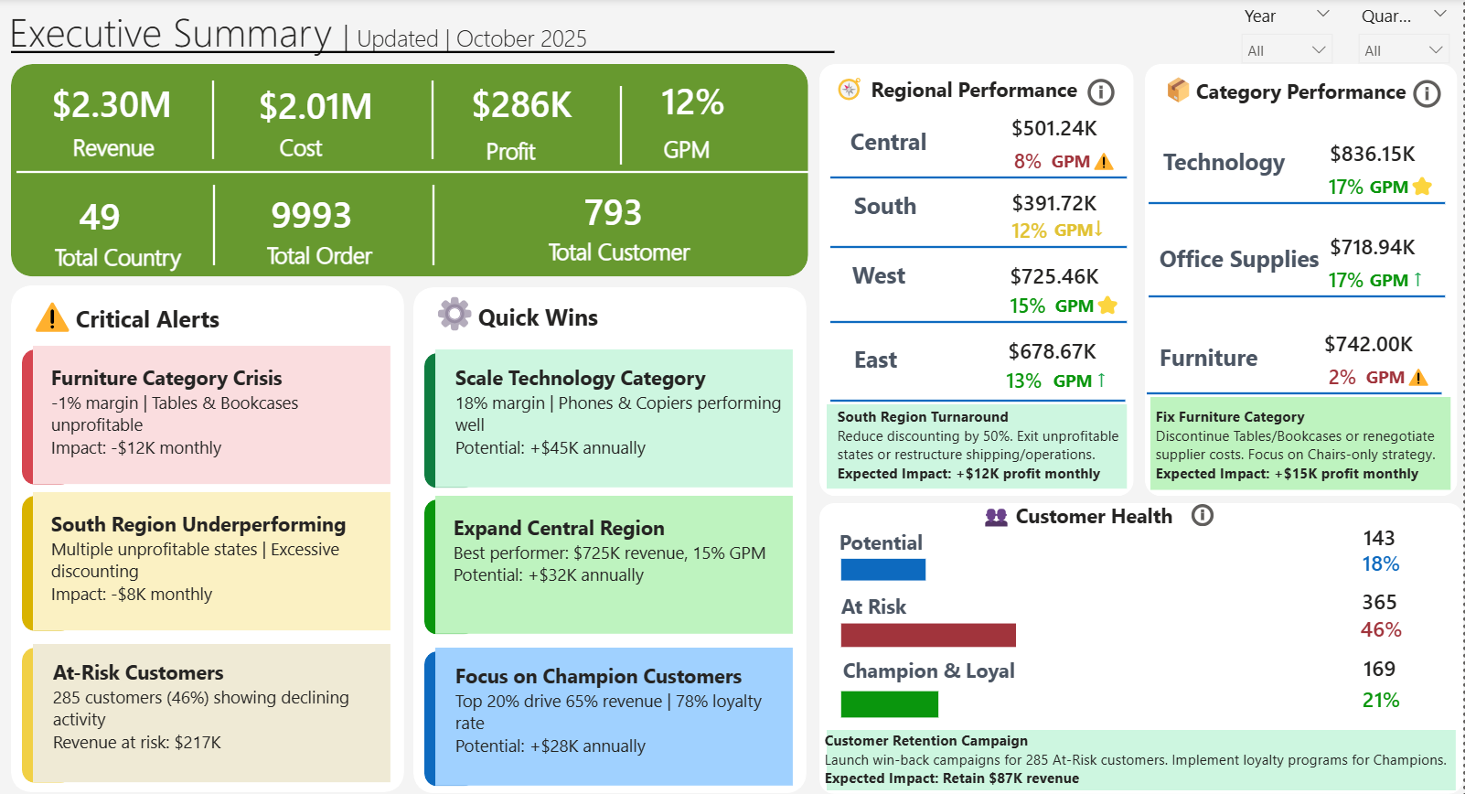
Figure 1: Executive Summary showing $2.30M revenue, 12% GPM, and critical business alerts
Key Metrics:
Total Revenue: $2.30M
Net Profit: $286K (12% GPM)
Customer Base: 793 customers across 49 countries
Order Volume: 9,993 orders
Average Order Value: $230
Critical Business Challenges
Our analysis reveals three urgent issues requiring immediate executive attention:
- Furniture Category Crisis (-1% margin, -$12K monthly impact)
- South Region Underperformance (Multiple unprofitable states, excessive discounting)
- Customer Churn Risk (365 customers at risk, representing 46% of customer base)

Customer Health Analysis
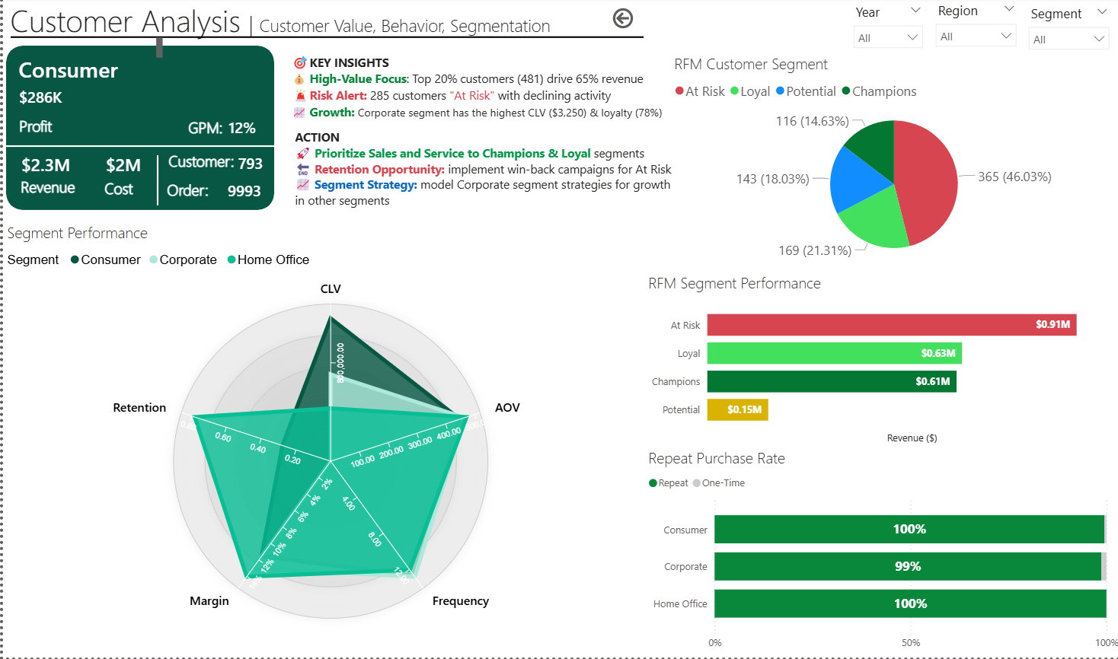
Figure 2: RFM segmentation revealing 46% of customers at risk with declining activity
Insights:
RFM (Recency, Frequency, Monetary) analysis segments customers into four strategic categories:
Segment | Customers | % of Base | Revenue | Key Characteristics
Champions | 116 (14.63%) | 15% | $0.61M | High CLV ($3,250), 78% loyalty rate
Loyal | 169 (21.31%) | 21% | $0.63M | Consistent purchasers, repeat buyers
At Risk | 365 (46.03%) | 46% | $0.91M | Declining activity, churn danger
Potential | 143 (18.03%) | 18% | $0.15M | Growth opportunity, nurture needed

Critical Findings
Customer Concentration Risk
Top 20% customers (481 accounts) drive 65% of total revenue
Corporate segment shows highest CLV ($3,250) and loyalty (78%)
Consumer segment has strongest repeat purchase rate (100%)
Churn Warning
365 customers (46%) classified as "At Risk" with declining activity
Revenue at risk: $910K annually
Average days since last purchase: 180+ days
Retention Performance
Consumer: 100% repeat purchase rate (strongest)
Corporate: 99% repeat rate
Home Office: 100% repeat rate

Recommendations
- Launch Win-Back Campaign for 365 At-Risk customers
- Targeted email sequence with personalized offers
- Prioritize Champions & Loyal Segments
- Dedicated account management
- VIP service tier implementation
- Loyalty rewards program
- Model Corporate Segment Strategies
- Apply high-performing tactics to Consumer and Home Office segments
- Focus on increasing CLV across all segments

Category Performance Analysis
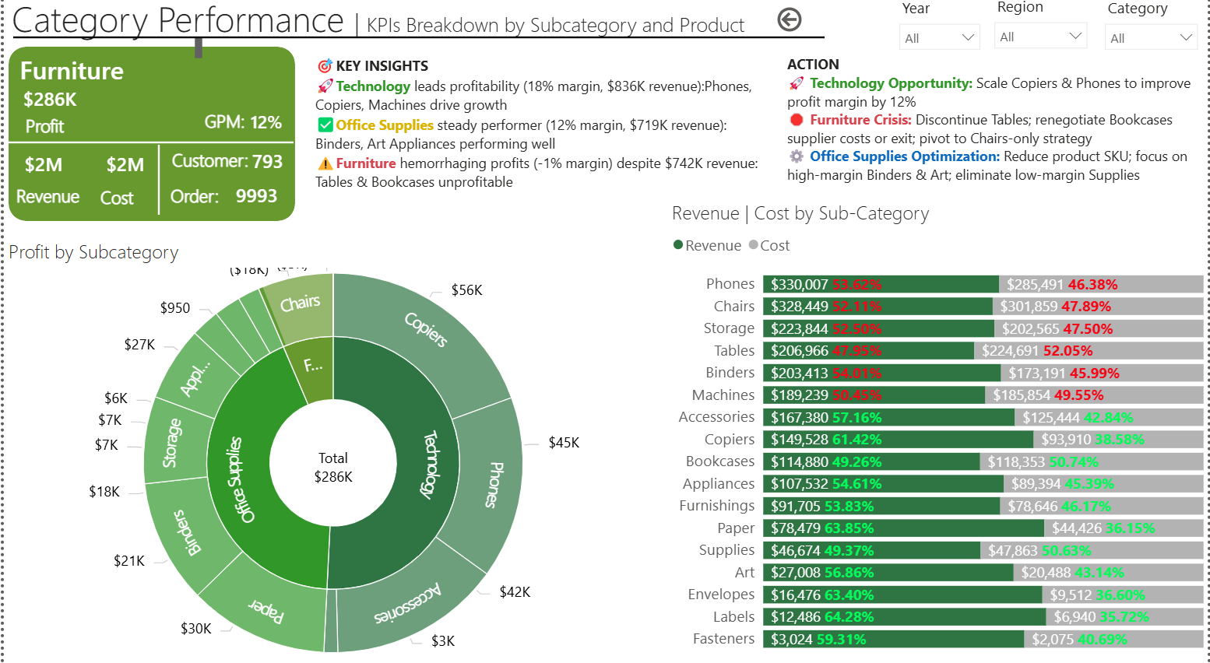
Figure 3: Product profitability showing Technology at 17% GPM while Furniture struggles at 2%
Product Portfolio Performance
Category | Revenue | Profit | GPM | Status
Technology | $836.15K | $142K | 17% | ✅ Best Performer
Office Supplies | $718.94K | $122K | 17% | ✅ Steady
Furniture | $742.00K | $15K | 2% | ⚠️ Crisis

Subcategory Deep-Dive
Top 5 Performers (by margin):
Paper: 63.85% margin ($78K revenue)
Labels: 64.28% margin ($12K revenue)
Envelopes: 63.40% margin ($16K revenue)
Copiers: 61.42% margin ($150K revenue)
Accessories: 57.16% margin ($167K revenue)

Bottom 5 Loss-Makers:
Tables: -52.05% margin ($207K revenue) ⚠️ Critical
Bookcases: -50.74% margin ($115K revenue) ⚠️ Critical
Machines: -49.55% margin ($189K revenue)
Chairs: -47.89% margin ($328K revenue)
Binders: -45.99% margin ($203K revenue)

Key Insights
Technology Category Excellence:
Phones & Copiers driving profitability
18% margin significantly above company average (12%)
Strong demand with consistent performance

Furniture Category Crisis:
Despite $742K revenue (32% of total), generates only $15K profit (2% margin)
Tables and Bookcases destroying profitability with negative margins >50%
Monthly loss: -$12K

Office Supplies Stability:
Steady 12% margin performance
Binders and Art supplies performing exceptionally well
Reliable revenue stream

Recommendations
Fix Furniture Category (Priority: High)
Discontinue Tables and Bookcases or renegotiate supplier costs
Focus on Chairs-only strategy
Expected impact: +$15K profit monthly

Scale Technology Products (Priority: High)
Increase marketing budget for Copiers and Phones by 12%
Expand product lines in high-margin categories
Potential: +$45K annually

Optimize Office Supplies (Priority: Medium)
Reduce SKU count by 20%, focus on high-margin Binders & Art
Eliminate low-margin supplies
Expected impact: +$8K annually

Regional Performance Analysis
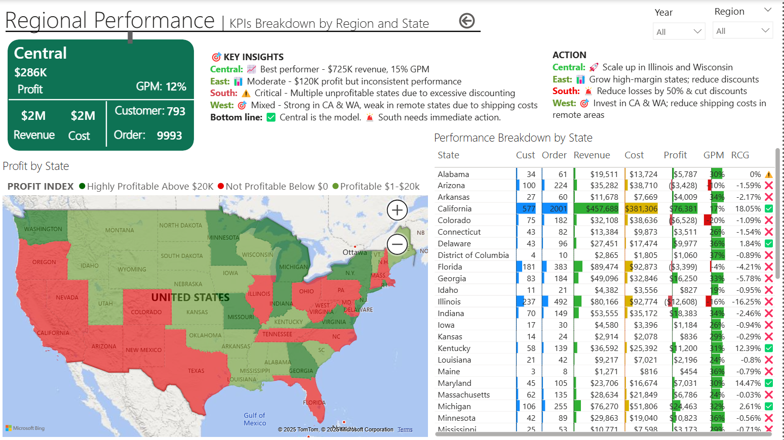
Figure 4: Geographic analysis showing Central region as best performer while South struggles
Regional Performance Summary
Region | Revenue | Profit | GPM | Status | Key Issue
Central | $725.46K | $109K | 15% | ⭐ Best | Model for expansion
West | $501.24K | $40K | 8% | ⚠️ Concern | High shipping costs
East | $678.67K | $88K | 13% | ✓ Good | Inconsistent performance
South | $391.72K | $47K | 12% | 🚨 Critical | Excessive discounting

State-Level Intelligence
Top 5 Profitable States:
California: $457K revenue, 18% GPM
New York: $310K revenue, 16% GPM
Texas: $171K revenue, 15% GPM
Washington: $139K revenue, 22% GPM
Pennsylvania: $116K revenue, 14% GPM

Problem States (Negative Profitability):
Arizona: -$3.4K profit (0% GPM)
Colorado: -$6.5K profit (0% GPM)
Florida: -$3.4K profit (4% GPM - below target)
Ohio: Significant losses due to shipping costs
Tennessee, North Carolina: Excessive discounting eroding margins

Geographic Patterns
Central Region Excellence:
Best performer: $725K revenue, 15% GPM
Illinois and Wisconsin driving profitability
Efficient shipping costs ($27/order vs $29 company average)
Model for operational efficiency

South Region Turnaround Needed:
Multiple unprofitable states
Root cause: Excessive discounting (average 18% vs 13% company average)
Shipping costs acceptable but margin erosion critical
Monthly impact: -$8K

West Region Shipping Challenge:
Strong revenue ($501K) but margin pressure (8% GPM)
California and Washington high shipping costs
Remote areas driving up delivery expenses
Opportunity: Regional fulfillment center

Recommendations
South Region Turnaround (Priority: Critical)
Reduce discounting by 50% (from 18% to 9%)
Exit unprofitable states or restructure shipping/operations
Expected impact: +$12K profit monthly

Scale Central Region (Priority: High)
Expand operations in Illinois and Wisconsin
Apply Central's best practices to other regions
Potential: +$32K annually

West Region Optimization (Priority: Medium)
Invest in California & Washington: Reduce shipping costs in remote areas
Consider West Coast fulfillment center (ROI analysis recommended)
Negotiate regional carrier rates
Expected impact: +$15K annually

Profitability & Cost Structure Analysis
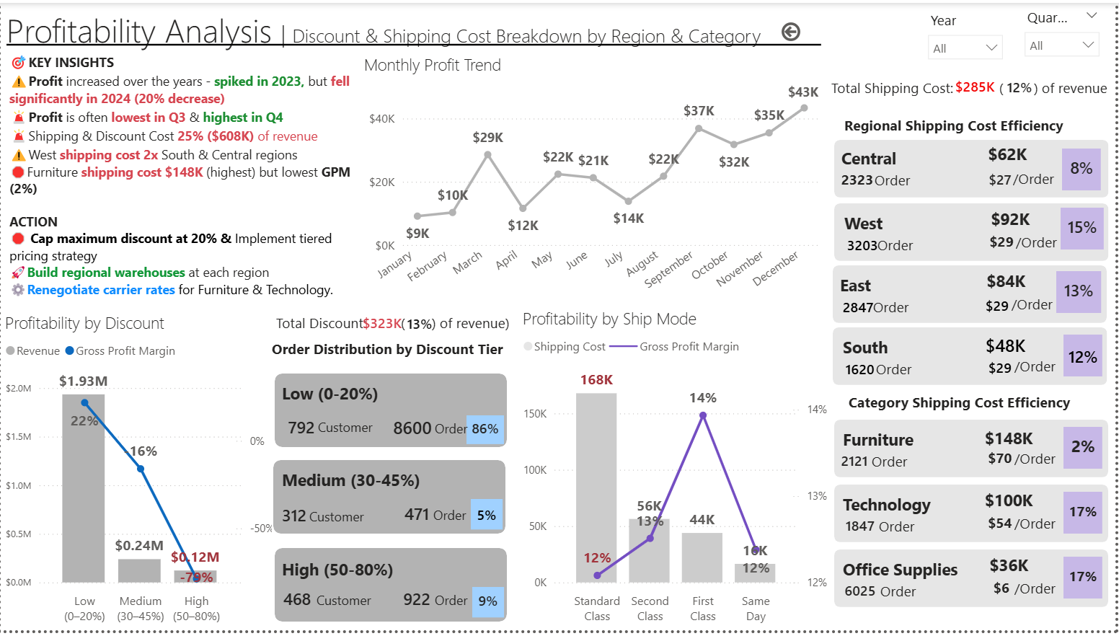
Figure 5: Cost breakdown showing shipping ($285K) and discounts ($323K) as primary profit drains
Profit Decomposition
Revenue to Profit Waterfall:
Gross Revenue: $2.30M
- Product Costs: ($2.01M) 87%
- Shipping Costs: ($0.29M) 12%
- Discount Impact: ($0.32M) 13%
= Net Profit: $0.29M 12% GPM
Cost Structure Breakdown
Cost Component | Amount | % of Revenue | Status
Product Costs | $2.01M | 87% | ⚠️ Above 85% target
Shipping Costs | $285K | 12% | ⚠️ High
Discounts | $323K | 13% | 🚨 Excessive
Returns/Other | $42K | 2% | ✓ Acceptable

Critical Findings
Shipping Cost Impact ($285K annually)
Regional Efficiency Variance:
Central: $62K total, $27/order (8% of revenue)
West: $92K total, $29/order (15% of revenue) ⚠️
East: $84K total, $29/order (13% of revenue)
South: $48K total, $29/order (12% of revenue)

Category Shipping Challenges:
Furniture: $148K (2% GPM) - $70/order average
Technology: $100K (17% GPM) - $54/order average
Office Supplies: $36K (17% GPM) - $6/order average

Discount Abuse ($323K annually, 13% of revenue)
Order Distribution by Discount Tier:
Low (0-20%): 792 customers, 8,600 orders (86% of total), 22% margin
Medium (30-45%): 312 customers, 471 orders (5%), 16% margin
High (50-80%): 468 customers, 922 orders (9%), -72% margin ⚠️

Profitability by Discount Level:
Low discount: $1.93M revenue, 22% gross margin
Medium discount: $0.24M revenue, 16% margin
High discount: $0.12M revenue, -72% margin (massive loss)

Shipping Mode Analysis
Profitability by Ship Mode:
Standard Class: 168K orders, 13% margin, 12% cost
Second Class: 56K orders, 14% margin
First Class: 44K orders, 14% margin
Same Day: 18K orders, 12% margin

Profit Trend Analysis
Key Observations:
Profit increased over years - spiked in 2023
Fell significantly in 2024 (20% decrease)
Profit often lowest in Q3 & highest in Q4
Shipping & Discount costs represent 25% ($608K) of revenue

Geographic Insight:
West shipping costs 2x South & Central regions
Furniture has highest shipping cost ($148K) but lowest GPM (2%)

Recommendations
Immediate Actions:
Cap Maximum Discount at 20% (Priority: Critical)
Implement tiered pricing strategy
Expected impact: +$23K profit monthly

Target: Reduce average discount from 13% to 8%
Optimize Shipping Strategy (Priority: High)
Build regional warehouses at each region to reduce shipping costs
Renegotiate carrier rates for Furniture & Technology
Expected impact: +$28K profit monthly

Exit High-Discount Customers (Priority: Medium)
468 customers generating 922 orders at -72% margin
Implement minimum margin thresholds
Expected impact: +$15K profit monthly

Strategic Recommendations
Immediate Actions (Q1 2025)
Initiative | Expected Impact | Implementation Cost | Timeline | Priority
Cap discounts at 20% | +$23K monthly | Low | 2 weeks | Critical
Discontinue Tables/Bookcases | +$15K monthly | Medium | 4 weeks | Critical
South region discount reduction | +$12K monthly | Low | 2 weeks | High
Win-back campaign for At-Risk | Retain $87K revenue | Medium | 6 weeks | High
Regional warehouse strategy | +$28K monthly | High | 12 weeks | High
Total Immediate Impact: +$608K annually

Medium-Term Initiatives (Q2-Q3 2025)
Technology Category Expansion
Scale Copiers and Phones marketing by 12%
Expected: +$45K annually

Central Region Expansion
Illinois and Wisconsin market penetration
Expected: +$32K annually

Customer Loyalty Program
Focus on Champions and Loyal segments
Expected: +$28K annually

Long-Term Strategy (Q4 2025+)
West Coast Fulfillment Center
ROI: 18-month payback
Annual savings: $50K+
Predictive Churn Model
ML-based early warning system
Retention improvement: 15-20%
Product Portfolio Rationalization
SKU reduction: 20%
Focus on top 20% performers

Risk Assessment
Critical Risks
Customer Concentration
Risk: Top 20% customers drive 65% revenue
Mitigation: Diversification strategy, expand middle-tier segment
Timeline: 6 months

Furniture Category Losses
Risk: -$12K monthly ongoing losses
Mitigation: Immediate discontinuation or supplier renegotiation
Timeline: 30 days

South Region Profitability
Risk: Multiple states unprofitable
Mitigation: Discount control, potential market exit
Timeline: 90 days

Implementation Roadmap
Phase 1: Emergency Measures (Weeks 1-4)
Week 1:
Implement 20% maximum discount policy
Communication to sales team
Update pricing in system
Week 2:
Analyze Tables/Bookcases supplier contracts
Initiate renegotiation or discontinuation process
Customer communication plan
Week 3:
Launch At-Risk customer win-back campaign
Email sequence deployment
Sales team outreach coordination
Week 4:
South region discount audit
Implement region-specific pricing controls
Performance monitoring dashboard

Phase 2: Strategic Optimization (Months 2-3)
Regional warehouse feasibility study
Technology category marketing scale-up
Customer loyalty program design
Carrier contract renegotiations

Phase 3: Growth Initiatives (Months 4-6)
Central region expansion execution
Product portfolio rationalization
Advanced analytics implementation
Performance measurement and adjustment

Expected Outcomes
Financial Impact (12-Month Projection)
Metric | Current | Target | Improvement
Revenue | $2.30M | $2.50M | +8.7%
Net Profit | $286K | $608K | +112.6%
Profit Margin | 12% | 24% | +12 pts
At-Risk Customers | 365 (46%) | 183 (23%) | -50%
Avg Discount Rate | 13% | 8% | -5 pts
Shipping Cost % | 12% | 9% | -3 pts

Strategic Outcomes
Customer Health:
Reduce churn rate by 50%
Increase Champion segment by 25%
Improve customer lifetime value by 30%

Operational Efficiency:
Reduce shipping costs by 25%
Improve discount discipline (cap at 20%)
Increase product portfolio profitability

Geographic Expansion:
Scale Central region operations by 20%
Fix South region profitability
Optimize West region shipping costs

Conclusion
This comprehensive analysis of SuperStore's business performance reveals significant opportunities for profit improvement. While the company demonstrates strong revenue ($2.30M) and a solid customer base (793 customers), three critical issues demand immediate attention:
Furniture category crisis costing $12K monthly
Excessive discounting eroding $323K annually
Customer churn risk threatening $910K in revenue
By implementing the recommended initiatives, SuperStore can achieve:
+$608K in annual profit improvement (112.6% increase)
50% reduction in at-risk customers
12-point improvement in profit margin (from 12% to 24%)
The roadmap is clear, the risks are manageable, and the potential returns are substantial. Executive leadership should prioritize the Phase 1 emergency measures immediately, with particular focus on discount control and furniture category rationalization.
Success depends on swift, decisive action in Q1 2025.

Project Owner: Oladigbolu Taofeek
Email: taofeekoladigbolu@gmail.com
GitHub: Taofeek-11/SuperStore-Business-Intelligence: SuperStore Business Intelligence Dashboard

Document Version: 1.0
Last Updated: November2024
Classification: Internal - Executive Review
Next Review Date: March 2025

This report is generated from live dashboard data. For interactive exploration, access the full dashboard at: [Dashboard Link]

